 | IQVIATM Work Instruction  Global Regulatory Affairs - Labeling - Creation  and maintenance of Local/Regional Product Labeling
Document Number and Revision:
CS_WI_RA0304 Revision 1
Document Owner:  Anja De Pauw | Author(s):  Kiran Chinnalla

PURPOSE
This document describes the process for creation and revision of local/regional product labeling, i.e., Prescribing Information (PI) & Patient Information Label (PIL).
This document also describes the requirements for appropriate communication and submission of new safety information impacting local/regional labels to respective national/country regulatory bodies or Health Authorities (HA).

SCOPE
This global Work Instruction (WI) applies to all staff within Global Regulatory Affairs (GRA) for:

  - Creating, revising, reviewing/approving, and issuing local/regional labeling

  - Communication and submission of new safety information impacting local/regional labeling documents
Local/Regional Product Labeling includes the content for product PI (e.g. Package Insert, Summary of Product Characteristics [SmPC], Product Monograph [PM]), Patient Information (e.g. Medication Guide, Package Leaflet) and product information on primary and/or secondary package labels (e.g. carton and container labeling).
This WI addresses product labeling content and does not cover packaging component design and approval.
This WI does not apply to promotional materials, clinical trial labeling, patient education materials or other Risk Management materials (or equivalents).

ROLES AND RESPONSIBILITIES
The following roles perform tasks described within this WI:

Role | Sections
Global Regulatory Lead (GRL) | 6.3, 6.4
Local Regulatory Affairs Expert (LRA) | 6.2, 6.3, 6.4, 6.6
Global Labeling Lead (GLL) | 6.2, 6.3, 6.4
Global Labeling Committee (GLC) | 6.4
Subject Matter Expert (SME) | 6.4

Page 1 of 15
Copyright © 2022. IQVIA. All rights reserved. The contents of this document are confidential and proprietary to IQVIA Holdings Inc. and its subsidiaries. Unauthorized use, disclosure or reproduction is strictly prohibited.

DEFINITIONS
Current Labeling: Product labeling that has been fully approved, saved into the appropriate electronic repository, and is intended to be used on current product.
Global Labeling Committee: Committee of Subject Matter Experts including, but not limited to Labeling, Safety, Clinical, Medical and Legal, to review and approve changes in Product Labelling.
Labeling Clinical Overview (LCOV): A document prepared by the Marketing Authorization Holder (MAH) to substantiate additions/deletions/modifications to Company Core Data Sheet (CCDS)/Company Core Safety Information (CCSI). This document is an addendum to Module 2.5 clinical overview.
Labeling Content: Content of labeling consists of text, tables, and figures inclusive of graphics, images, illustrations, logos, photographs, charts, and symbols that convey information as it relates to the identity and safe and effective use of a product. This information may be provided in a number of different formats depending on the type of labeling and/or regulatory need.
Prescribing Information: Documents that contains instructions on the intended use, how to dose, warnings and precautions, adverse reactions, and other important product information. Prescribing Information is designed for use by healthcare professionals (HCPs) and contains the safety and efficacy information for the product, e.g., SmPC in Europe, United States Prescribing Information (USPI) in United States, Product Monograph (PM) – Health Professional Information in Canada.
Patient Information: Documents that contains non-specific terms for any information about a condition or procedure which is intended for consumption by a non-healthcare audience/patients. Patient Information lables are derived from Prescribers information.
Packaging Label Component: Labeling material that the product is contained within during shipment and/or administration, including labels that are applied to the container of the product. Examples of packaging label components include, but are not limited to, vial labels, bottle labels, individual cartons, intermediate cartons, tertiary cartons, shipping labels.
Local/regional Labels: Labels, including but not limited to, PI, Instructions for Use, PILs and Package Components.
Reference Label: Any label that serves as basis for creation/update of local/regional product labeling, e.g., Branded label/ Innovator label for generic products, United States (US)/Europen Union (EU) label for rest of the world local/regional product information.
Source document/Information: Supporting document/literature that describes the efficacy/safety/quality topics in detail based on the clinical or post-marketing or regulatory observations, e.g., Signal Evaluation Report, Periodic Safety reports, Clinical Study reports, Quality Summary.
Subject Matter Expert (SME): Functional expert(s) responsible for confirming the content of labeling is accurate, complete, clear, based on evidence/scientific rigor (e.g.,

Medical and scientific information, adverse event reporting, customer requirements, clinical trials) and conformance to applicable regulatory requirements. Appendix A provides a list of identified SMEs.

MATERIAL AND EQUIPMENT
Not Applicable

PROCEDURE

  - Conditions that trigger either creation or update of local/regional product labels
Following scenarios will trigger local/regional product label creation or update:
    - Creation:
      - Market Authorization Application (MAA)
      - When deemed necessary by the MAH
    - Update:
      - Creation or update of CCDS
      - Health Authority (HA) request for a labeling change (outside of the standard submission and approval process), for example, Health Authority review of safety reports, or requirement for class labeling
      - Quality/Chemistry, Manufacturing & Controls (CMC) change (e.g. storage conditions)
      - Proposed revision based on local review, for example, local (safety or efficacy) data, or change in local legislation basis label update
      - Reference label update
      - HA query/recommendations
      - Pharmacovigilance Risk Assessment Committee (PRAC) notifications, referrals, renewal outcomes
      - Pharmacovigilance data including, but not limited to, a confirmed safety signal
      - Other administrative changes (e.g., address)
  - Creation of new local/regional product labels

No: | Who: | Step: | When:
6.2.1 | LRA | - Receives notification of a request to create local/regional product labels from the MAH  - Notifies the GLL | At the start of the project
6.2.2 | GLL | Sends the request to SMEs (refer to Appendix A) and any additional MAH contact Person(s) listed in the GRA project files. | Within 1 business day of receipt of the notification
6.2.3 | GLL | Schedules the Kick-off meeting with internal and client SMEs, GRL and other stakeholders to discuss on approach and timelines. | After SMEs and other MAH stakeholders have been contacted

No: | Who: | Step: | When:
6.2.4 | GLL | - Determines the local/regional product labeling specific template (e.g., latest Quality Review of Documents (QRD) template in Europe)  - Receives and reviews source documents from the client | After the Kick-off meeting
6.2.5 | GLL | - Drafts the English version of the local/regional product labeling with input from SMEs  - If applicable, align with CCDS or base/reference label.  - If there are differences with the CCDS or base/reference label, prepare and submit content deviation form (Appendix B) to the GLC for review. (Go to Section 6.4 for review and approval). | After reviewing source documents
6.2.6 | LRA | If applicable, translates the local/regional product labels to the desired official language(s) as per the national HA requirement. Refer to CS_WI_RA0262: Global Regulatory Affairs - Translation of documents. | After creating draft local/ regional product labels in English
6.2.7 | LRA | Performs Quality Check (QC) of the draft local/regional product label (content and translation accuracy). Refer CS_WI_RA032: Global Regulatory Affairs – Preparation, Quality Control and Provision of Regulatory Affairs Deliverables. | After creating draft local/ regional product labels
6.2.8 | GLL | Submits local/regional product labels (Prescriber and patient information) to GLC for review if the label is:  - Submitted before the CCDS is available  - New USPI, EU SmPC/PIL (Centralized Procedure (CP), Mutual Recognition Procedure (MRP), Decentralized Procedure (DCP), National Procedure (NP)), other local/regional Product Information  Go to Section 6.4 for review and approval steps. | After performing the QC of draft local/regional product labels

  - Update of local/regional product labels

No: | Who: | Step: | When:
6.3.1 | GRL/LRA | Informs the GLL about the trigger for local/regional label update via email. | As soon as the new information is identified as detailed in section 6.1
6.3.2 | GLL | Identifies the timeframe for the submission of updated/revised local/regional labels based on trigger:  - Immediate Update – Local/regional label shall be revised and submitted within 60 calendar days from trigger.  - Non-Immediate Update – Local/regional label shall be revised and submitted within 90 calendar days from trigger.  - Other Update – Local/regional label shall be revised and submitted within 120 calendar days from trigger. | After notification of the trigger

No: | Who: | Step: | When:
- If minor changes, and no immediate submission to HA is required, notifies the changes to HA at a later date, if required by the HA.
Note: Timeframe may be adjusted based on MAH and respective country HA requirement.
6.3.3 | GLL | - Schedules the Kick-off meeting with internal and client SMEs, GRL, LRA and other stakeholders to discuss on approach and timelines  - Documents the outcome from the Kick-Off meeting. | After identification of the timeframe for submission
6.3.4 | GLL | Sets up a meeting with appropriate SMEs to collect source documents. | After the Kick-off meeting
6.3.5 | LRA | Creates draft regional/ local product labels based on supporting information. | After reviewing source documents
6.3.6 | GLL | Drafts Labeling Clinical Overview (LCOV) Addendum to Clinical Overview (ACO)/Justification document based on the supporting information. | After creating draft regional/ local product labels
6.3.7 | LRA | If applicable, verifies alignment with CCDS or base/reference label. (Refer to CS_WI_RA0303 Global Regulatory Affairs - Labeling – Creation and maintenance of Company Core Data Sheets/ Company Core Safety Information, section 6.7 Harmonize Local/Regional Labels with the new/updated CCDS/CCSI/RSI). If there are differences, prepares and submits content deviation form (Appendix B) to GLC for review. (Go to Section 6.5). | After drafting local/regional product labels
6.3.8 | LRA | If applicable, translate the local/regional product labels to the desired official language(s) as per the national HA requirement. Refer to CS_WI_RA0262: Global Regulatory Affairs - Translation of documents. | After creating draft local/ regional product labels in English
6.3.9 | LRA | Performs QC of the draft local/regional product label (content and translation accuracy). Refer CS_WI_RA032: Global Regulatory Affairs – Preparation, Quality Control and Provision of Regulatory Affairs Deliverables. | After creating draft local/ regional product labels

  - Review and Approval of new/updated local/regional product labels

No: | Who: | Step: | When:
6.4.1 | GLL | Distributes the (new/updated) local/regional product labels review package to the SMEs for review. | Draft local/regional product labels are available for review
6.4.2 | SME | Reviews the respective efficacy/safety/quality sections and associated supporting documents/literature and provides documented comments to GLL/LRA. | Upon receipt of the draft local/regional product labels

No: | Who: | Step: | When:
6.4.3 | LRA | If required, internally approves the local/regional product labeling in the Document Management System (DMS) and update the tracking system. | After the changes/ content in the local/regional product labels is acceptable
6.4.4 | GRL | Reviews the overall local/regional product labeling in line with Regulatory strategy and intelligence. Provides documented comments to GLL/ Local/Regional Representative. | Draft local/ regional product labels are available for review after SME review
6.4.5 | GLL | Consolidates and documents the comments from GRL/SMEs and, if required, schedules cross-functional review meeting(s).  Documents the outcomes from the meetings. | Receipt of reviewers’ comments
6.4.6 | LRA | Updates the local/regional label in accordance with section 6.3. | Revisions to local/ regional product labels required
6.4.7 | GLL | Distributes the (new/updated) local/regional labeling review package to the SMEs for review via email. | Draft local/regional product labels are available for review
6.4.8 | GLL | Schedules a GLC review meeting and distributes the review package to the GLC. | After determining if GLC review would be required, e.g., local/regional label safety content is deviating from CCDS/CCSI, HA  recommendations/ mandates
6.4.9 | GLC | Reviews (new/updated):  - Local/regional product labels along with LCOV/ Justification Document and if applicable  - Content deviation forms for approval (refer to Appendix B)  - Provides comments and/or changes to GLL/Local/ Regional Representative, as needed. | Prior to GLC meeting
6.4.10 | GLL | Presents the local/regional product labels along with LCOV/ Justification Document and if applicable, content deviation forms to the GLC members via a PowerPoint presentation. CS_TP_RA0305 (Global Regulatory Affairs - Labeling - GLC slides) provides an example template. | During the GLC meeting
6.4.11 | GLC | Provides approval or recommendations for further changes  Issues and distributes meeting minutes, including approvals and recommendations. Documents GLC approval in tracking system. | During the GLC meeting
6.4.12 | GLL | Communicates the approval and/or recommendations of the GLC to the respective SMEs. | Post GLC meeting

No: | Who: | Step: | When:
6.4.13 | GLL | Returns to Section 6.4.3. | Post GLC meeting if SME update required to local/ regional product labels and justification documents
6.4.14 | GLL | Updates the CCDS/CCSI/LCOV and requests GLC approval if required. | Post GLC meeting if non-SME updates are required
6.4.15 | GLL | Documents GLC approval in Tracking system (refer to Appendix C) and notifies the GLL/LRA. | After GLC Approval

  - Communication and Submission of new/updated local/regional product labels
Refer to CS_WI_RA0279 Global Regulatory Affairs - Regulatory Submissions - Post Approval Changes to Registered Details including CMC, Administrative and Safety Changes.

  - Post submission of new/updated local/regional product labels

No: | Who: | Step: | When:
6.6.1 | LRA | Updates and reviews local product labeling per HA comments and recommendations until final product labeling content is agreed. | If HA issues comments/ recommendations
6.6.2 | LRA | Consults with GRL, GLL or SMEs, as appropriate, during HA labeling review/negotiations and escalate to GLC as appropriate by email. A GLC meeting will be convened if required. | If HA issues comments/ recommendations or if differences from CCDS, Base/Reference label are identified
6.6.3 | LRA | Compares the final HA approved label against the CCDS or basis/reference label and provide any differences to GLL. Content differences/deviations are recorded in the tracking system. | After finalization of local/regional product information by HA
6.6.4 | LRA | Verifies that the summary of any approval local exceptions is recorded in the tracking system. | After comparing and identifying differences between CCDS or base/reference label with finalized local/regional product information

6.6.5 | LRA | Updates the submission tacking system with approval information, including approval letter, final local product labeling for archival in the DMS. | After approval of final local/regional product information
6.6.6 | LRA | - Distributes final HA approved label to stakeholders within 5 working days from the HA approval date.  - Notifies EU QPPV for eXtended EudraVigilance Medicinal Product Dictionary (XEVMPD) updates. Refer to CS_WI_LS0025 for more details. | After updating the tracking system and DMS with approved local/ regional product information
6.6.7 | LRA | Supports implementation of approved local/regional product labeling into finished product, and upload onto local websites, as appropriate, per local regulatory requirements and timelines. Update the tracking system (refer to Appendix C). | After approval of final local/regional product information

- SUPPORTING DOCUMENTATION

DOCUMENT NUMBER | TITLE
ESOP References
7.1 CS_WI_RA0279 | Global Regulatory Affairs - Regulatory Submissions - Post Approval Changes to Registered Details including CMC, Administrative and Safety Changes
7.2 CS_WI_RA0303 | Global Regulatory Affairs - Labeling - Creation and Maintenance of Company Core Data Sheets / Company Core Safety Information
7.3 CS_WI_RA032 | Global Regulatory Affairs - Preparation, Quality Control and Provision of Regulatory Affairs Deliverables
7.4 CS_TP_RA0305 | Global Regulatory Affairs - Labeling - GLC slides
7.5 CS_WI_RA0262 | Global Regulatory Affairs - Translation of documents
7.6 CS_WI_LS0025 | Lifecycle Safety-Safety Communications and XEVMPD

- SUPERSEDES

DOCUMENT NUMBER | TITLE | REVISION NUMBER
Not Applicable | Not Applicable | Not Applicable

- MODIFICATION FROM PREVIOUS REVISION

CHANGE | SECTION REFERENCE | JUSTIFICATION
This is a New Document | Not Applicable | To provide the local labelling process which follows on from the creation and maintenance of CCDS, described in CS_WI_RA0303

- APPENDICES

  - Appendix A: Subject Matter Expert Matrix for Labeling Content Development

  - Appendix B: Content Deviation Form

  - Appendix C: Label Tracking System - Tracking Fields

  - Appendix D: Flowchart

Appendix A: Subject Matter Expert Matrix for Labeling Content Development
The following table is intended to identify the Subject Matter Experts (SME) for Labeling Content Development.
The SME is the decision maker accountable for verifying accuracy of the labeling content element and for verifying the labeling content meets requirements. The SME is also responsible for reviewing label content for consistency between label components within a product code or family and approving labeling content, specific to his or her area of expertise.

Labelling Content Element | Subject Matter Expert (SME)
Product Name | Marketing (Branded), Regulatory, Trademark
Logos | Corporate Communications
Client Logos (Private Label) | Client and Marketing
Product Description (e.g., qualitative and quantitative composition, pH, osmolarity, product overview, dosage form, strength) | Quality
Posology/Dosing | Clinical
Indications for use | Marketing, Clinical, Regulatory
Contraindications | Clinical, Safety
Warnings and Precautions | Clinical, Safety (supported by Risk Management Team)
Drug Interactions | Clinical Pharmacology, Safety
Fertility, Pregnancy and Lactation | Clinical, Safety & Non-Clinical (as appropriate)  Clinical: Review and Summary of published literature regarding product use in pregnant and lactating women and effects on male/female fertility.  Safety: Cumulative review and summary of relevant cases in the PV database  Non-Clinical: Review and Summary of pre-clinical information, including published literature.
Effects on the Ability to Drive and Use Machines | Clinical
Adverse Reactions | Safety/Pharmacovigilance
Pharmacological Properties (Pharmacodynamic and Pharmacokinetic properties) | Clinical/Clinical Pharmacology with support from Non-clinical should they need it (most of the time there will be clinical data to support the pharmacological properties).
Directions/Instructions for Use | Clinical
Product Images | Packaging
Storage/ Stability/ Shelf-Life | Packaging
Pack sizes etc. (How supplied) | Marketing
Registration/Application number | Regulatory
Local identification number (e.g., NDC, DIN, KDC, etc.) | Regulatory
Product code (e.g., 2B004) | Marketing
Trademarks | Trademark Legal

Labelling Content Element | Subject Matter Expert (SME)
Distributed by Statement | Regulatory
Manufactured by Statement | Regulatory
Country of Origin | International Trade Compliance
Phone numbers/website addresses to report Adverse Events | Safety/Pharmacovigilance
Phone numbers/website addresses to contact Service | Regulatory
Labelling Revision Date for Package Insert or Instructions For Use | Labelling
Label Part number | Labelling
Labelling Specification Element
Global identification number (GTIN) | Packaging or Manufacturing Liaison
Barcodes | Packaging or Manufacturing Liaison
UDI barcode metadata | Packaging
Formatting Element
Overall label differentiation in layout | Human factors
Overall label design | Labelling

Appendix B: Content Deviation Form

Product Name: Click here to enter text. | RSI version/date: Click here to enter text and date.
Country: Click here to enter text. | Date of request: Click here to enter date.
Contact Name: Click here to enter text. | Contact Details: Click here to enter details.
This form should be used when local Product Labeling has differences to the CCDS OR Reference Safety Information (RSI) OR an approved (Basis) label, for example, when:
- A new or updated CCDS/RSI is issued*
- An approved label is updated*
- An LRA proposes a change that is not aligned with the CCDS/RSI or approved label (i.e. locally initiated change)*
- A Health Authority request is received (outside of an ongoing regulatory procedure)
- Reporting any differences required by a Health Authority during the review process that were not previously reviewed by Global Labeling (GL).
Please select whether local Product Labeling aligns with the CCDS or RSI or an approved  (Basis) label | Please provide a brief summary of the reason why a Content Deviation is requested
Local Product Labeling aligns with:  D the CCDS, but has differences.  D an RSI, but has differences.  D an approved (basis) label, but has differences. The approved label used is: | Reason for request: Click here to enter text.
Please then provide, in English, details of deviations that do not align, either:
- By attaching a copy of your local Product Labeling with a reason for each deviation, or
- By completing the table below, summarizing a reason for each deviation.

Section | CCDS / RSI /  Approved Label text  (as applicable) | Local Product Labeling text  (as previously approved  or proposed text) | Rationale for difference | GLL Assessment

GL Review Summary:
Summary of APPROVED deviations:  - Click here to enter text. | Summary of REJECTED deviations:  - Click here to enter text.
Action for LRA:  - Click here to enter text. | Action for LRA:  - Click here to enter text.
Date of GL review finalization:

Appendix C: Label Tracking System - Tracking Fields

- Active substance
- Trade name
- Pharmaceutical Form & Strengths
- Request Created Date
- Day 0 (If applicable)
- Global Impact Assessment Date
- GLC Approval Date
- CCDS Sign- off Date
- CCDS Distribution Date
- Country(ies) Acknowledgement Date
- Country Dependency
- Local Impact Assessment Date
- Reason for Submission Deferral
- Justification for submission deferral (If any)
- Deferral Rejection/Approval Date
- LPD Sign-off Date - English
- Translated LPD Sign- off Date - Non-English (If Applicable)
- HA Submitted/ Notified Date
- HA Last Corresponds Date
- Label Public Listed Date
- Commercial Artwork Sign-off Date
- Commercial Artwork intake form Approved
- Last Artwork of a SKU Approved
- Bill of material changed over (BOM)
- First batch released at package site
- Available to ship from last point of control
- First Ship with New Artwork
- Last ship with old Artwork

Appendix D: Flowchart
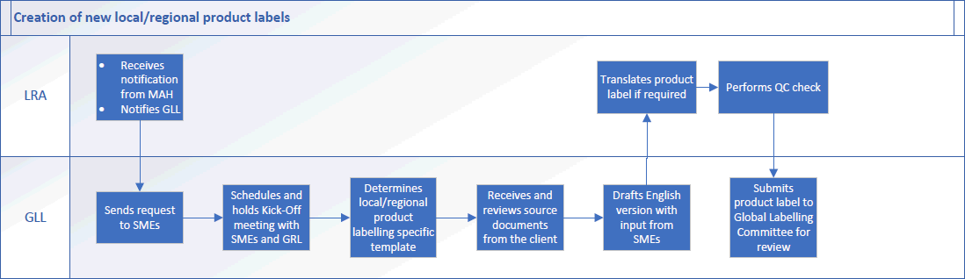

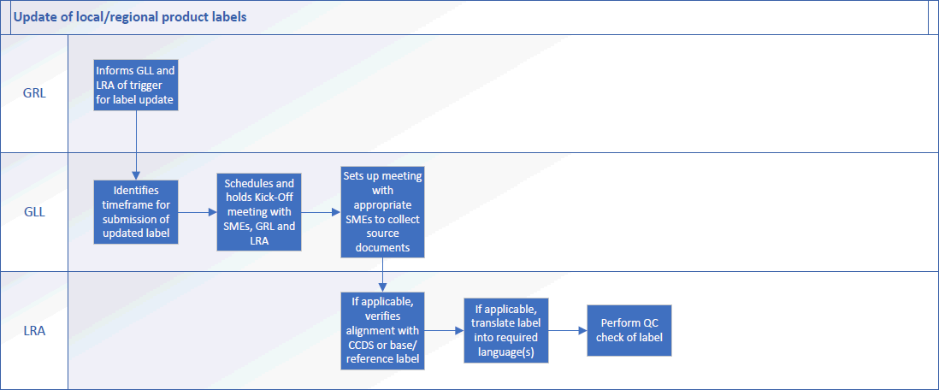

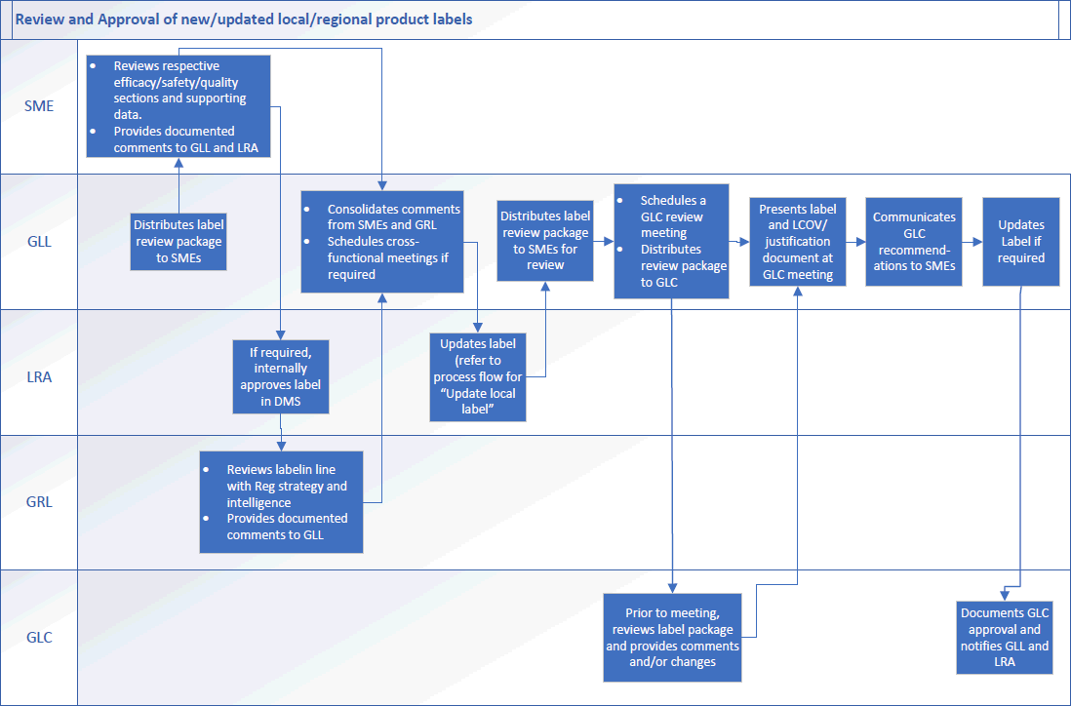
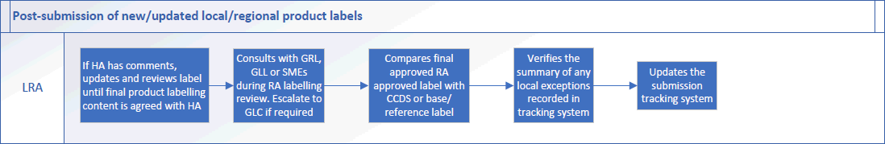

Page 15 of 15
Copyright © 2022. IQVIA. All rights reserved. The contents of this document are confidential and proprietary to IQVIA Holdings Inc. and its subsidiaries. Unauthorized use, disclosure or reproduction is strictly prohibited.

UserName: Lewicky, Tamara (q730348) Title:
Date: Tuesday, 12 April 2022, 11:23 AM Eastern Daylight Time Meaning: Signing this Document Indicates My Approval
================================================

UserName: Kemp, Jaco (q608126) Title:
Date: Tuesday, 12 April 2022, 12:19 PM Eastern Daylight Time Meaning: Signing this Document Indicates My Approval
================================================

UserName: Corley, Helen (q730385) Title:
Date: Tuesday, 12 April 2022, 12:45 PM Eastern Daylight Time Meaning: Signing this Document Indicates My Approval
================================================

UserName: Nandikonda, Sruthi (u1076598) Title:
Date: Tuesday, 12 April 2022, 03:03 PM Eastern Daylight Time Meaning: Signing this Document Indicates My Approval
================================================

UserName: SENGAR, SATISH (q1036027)
Title:
Date: Wednesday, 13 April 2022, 01:50 AM Eastern Daylight Time Meaning: Signing this Document Indicates My Approval
================================================

UserName: Singh, Priti (q823374) Title:
Date: Wednesday, 13 April 2022, 03:38 AM Eastern Daylight Time Meaning: Signing this Document Indicates My Approval
================================================

UserName: Dobrychlop, Karolina (q1025820) Title:
Date: Wednesday, 13 April 2022, 05:49 AM Eastern Daylight Time Meaning: Signing this Document Indicates My Approval
================================================

UserName: Kennedy, Jillian (q600133) Title:
Date: Wednesday, 13 April 2022, 06:42 AM Eastern Daylight Time Meaning: Signing this Document Indicates My Approval
================================================

UserName: NAJI, Kenza (u1090913) Title:
Date: Wednesday, 13 April 2022, 08:21 AM Eastern Daylight Time Meaning: Signing this Document Indicates My Approval
================================================

UserName: Glizer, Veronica (q735279) Title:
Date: Wednesday, 13 April 2022, 04:21 PM Eastern Daylight Time Meaning: Signing this Document Indicates My Approval
================================================

